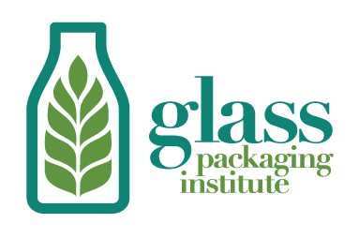
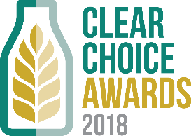

Media Contact:
Lynn Bragg
Glass Packaging Institute
Phone: 703.684.6359
Email: lbragg@GPI.org

Enter Your Glass Package to Win A 2018 Clear Choice Award

New Award this Year for ‘Sustainability’

Arlington, VA (April 24, 2018) – The Glass Packaging Institute is pleased to announce that it is now accepting submissions for the 2018 Clear Choice Awards. This is the only awards program for North America that recognizes the contribution glass packaging makes to the image and success of everyday products.

The Awards are open to all North American glass container manufacturers and their customers to submit products introduced between August 2017 and August 2018. Products may be entered for an award in one of nine categories. See all the submission guidelines and enter by August 17, 2018 to win recognition as the “best in glass”: www.ClearChoiceAwards.com.

New this year is a ‘sustainability’ award category. "While all glass bottles and jars are 100% and endlessly recyclable as well as ocean-friendly, this category recognizes glass containers that feature innovation in light-weighting, high recycled content, returnable and refillable bottles, and more,” said Lynn Bragg, GPI President.

An independent panel of leaders from the food and beverage media and industry, sustainability sector, and design and packaging professionals will judge each submission on four criteria: innovation, package design, shelf impact, and how well the package tells the story of the brand, product or sustainability initiative.

“We look forward to seeing this year’s submissions,” said Bragg. “Glass bottles and jars are not only naturally beautiful, but glass is a sustainable and healthy choice that delivers on taste and premium appeal.”

The 2018 Clear Choice Awards winners will be announced at the Packaging That Sells Conference in Chicago, IL, on October 9, 2018. Award winners will also be featured in a variety of digital and print media. Submit your entry: www.ClearChoiceAwards.com.

Entries for the 2018 Clear Choice Awards are also eligible for the BRANDPACKAGING People’s Choice Glass award given out at Packaging That Sells, as well as placement in the December Design Gallery branding and design annual.

About the Glass Packaging Institute
The Glass Packaging Institute (GPI) is the trade association representing the North American glass container industry. Through GPI, glass container manufacturers speak with one voice to advocate industry standards, promote sound environmental policies and educate packaging professionals. GPI member companies manufacture glass containers for food, beverage, cosmetic and many other products. GPI also has associate members that represent a broad range of suppliers and closure manufacturers. Learn more at www.GPI.org, UpgradeToGlass.com and GlassRecycles.org. Follow on Twitter and Facebook @ChooseGlass.

